**01 Excel Basics**

**The interface of the excel**

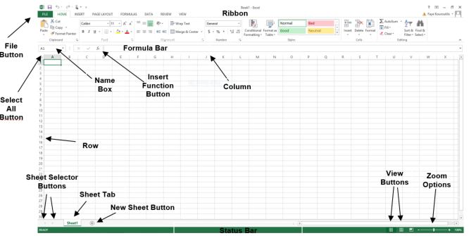

**Autofill on the excel**

* Select the cells 🡪 File 🡪 options 🡪 advanced 🡪 edit custom lists 🡪 import 🡪 ok 🡪 ok
  + When select the cell and drag down it will repeat the selected cells

**Make comment on specific cell**

* Select the cell 🡪 right click 🡪 insert comment

**Remove comment on specific cell**

* Select the cell 🡪 right click 🡪 delete comment

**Delete the cell content**

* Select the cell 🡪 right click 🡪 clear content

**Fit the cell width to the cell content**

* Select all cells 🡪 double click to the first column line

**Filter the data**

* Select the table 🡪 data 🡪 filter 🡪 small arrow will appear on the table
  + Select any arrow 🡪 sort smallest to largest
  + Select any arrow 🡪 sort A to Z
  + Select any arrow 🡪 sort by color

**Search on the table**

* Select the table 🡪 data 🡪 filter 🡪 search

**Show repeated data on the table**

* Select the table 🡪 home 🡪 conditional formatting 🡪 highlight cells rule 🡪 duplicate values
  + Will highlight the cells the have the same value

**Clear the highlighted cells color**

* Select the cells 🡪 clear rules from selected cells

**Highlight cells based on condition**

* Select the cells 🡪 home 🡪 conditional formatting 🡪 [ select the condition ]

**Some functions on Excel**

* **SUM ()** 🡪 summation specific cells
* **MIN()** 🡪 get the minimum value on a range of cells
* **MAX()** 🡪 get the maximum value on a range of cells
* **COUNT()** 🡪 this return the number of records/cells
* **AVERAGE ()** 🡪 get the average value of the selected cells
* **LARGE(array, k)** 🡪 return the largest value in a range of numbers
  + array: the range or array of numeric values
  + k: the position (from the largest) you want to retrieve
  + **example**: LARGE(A1:A10, 3)
    - get the third largest number
* **SMALL(array, k)** 🡪 get the smallest value on array or range
  + array: the range or array of numeric values
  + k: the position (from the largest) you want to retrieve
  + **example**: SMALL(A1:A10, 3)
    - get the third smallest number
* **COUNTA()** 🡪 this used to count the names [text]
* **COUNTBLANK()** 🡪 this used to count the blank values
* If we have any equation on the excel sheet, when change any value of the cells of the equation; will change the result of the equation
  + To enable or disable this:
    - Formulas 🡪 calculation options 🡪 [automatic, manual]
    - If you make the calculation option ***manual*** you must select formulas 🡪 calculate now
    - If you make the calculation option ***automatic***, the equation result will be automatically changed

**how to find the cells that shared on the equation**

* Formulas 🡪 trace precedents

**Get the current date**

* =TEXT(TODAY(), "dd-mm-yyyy") # 28-07-2025
* =TEXT(TODAY(), "dddd, dd mmmm yyyy") # Monday, 28 July 2025
  + **TEXT()**: is a function that format a date inside a formula
  + dddd: this used to represent the day name